**Use git with eclipse**

1. Open the project which you want to be pushed to git in eclipse.
2. Go to Windows -> Preferences

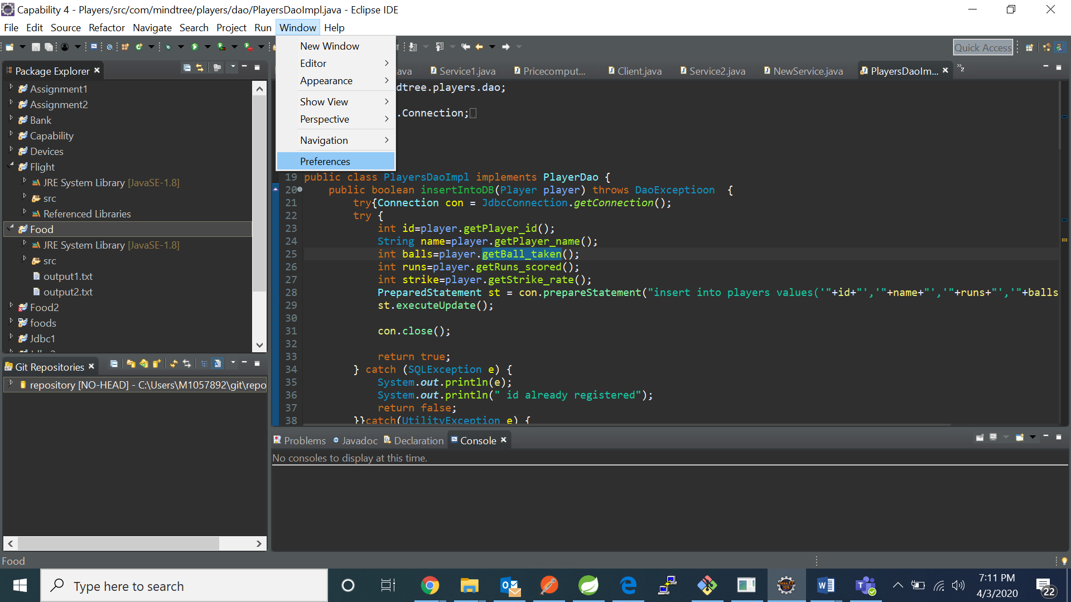

1. Click on add entry:

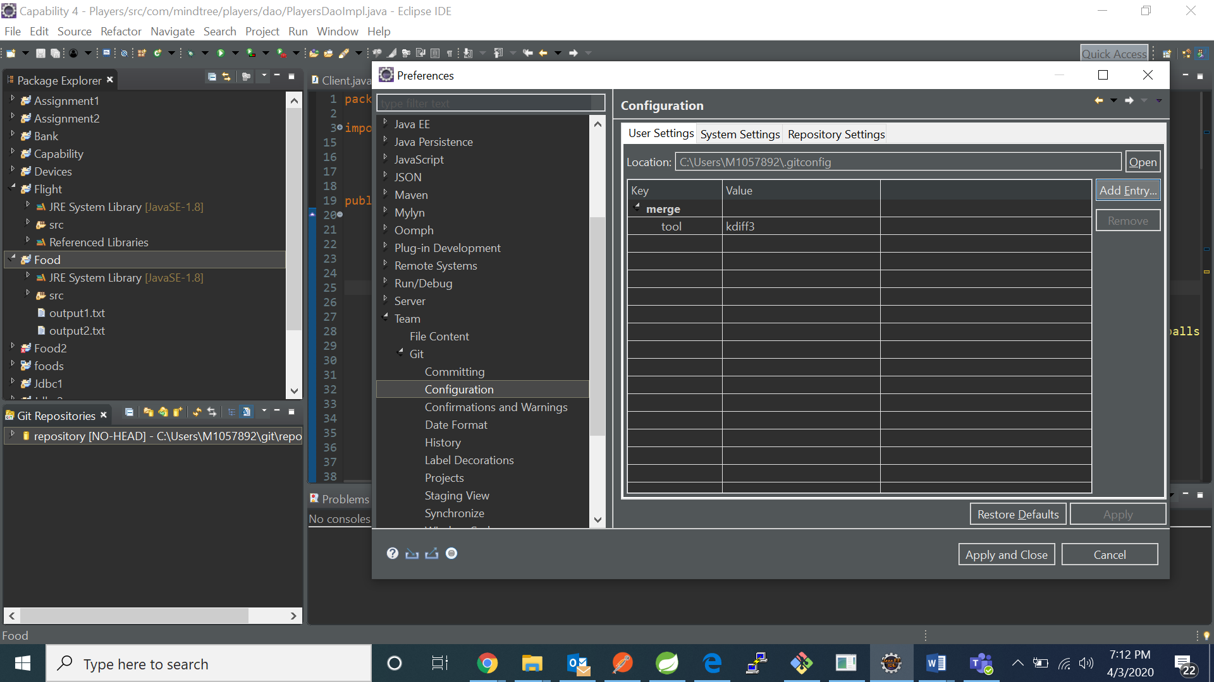

1. Under key write “**user.name**” and in value your username and then ok. 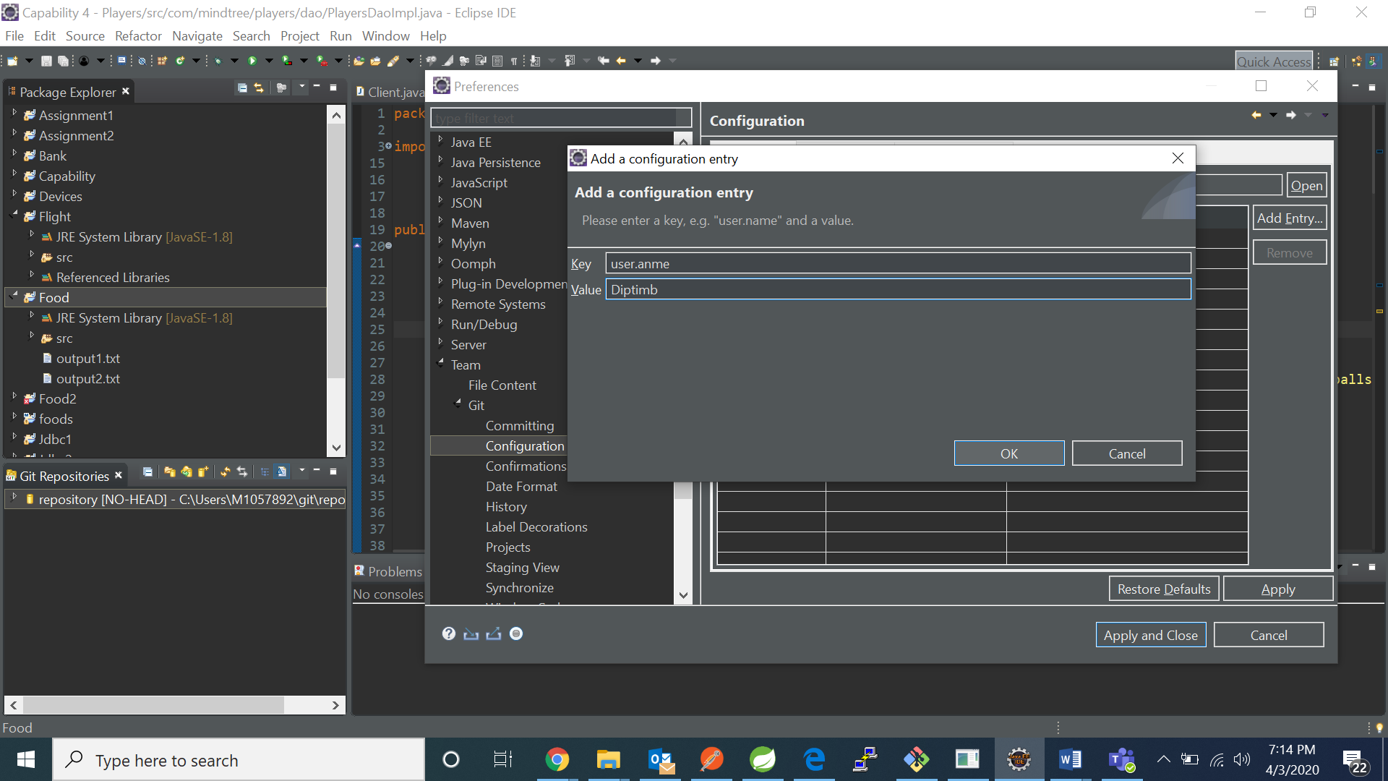
2. 5. Click on add key again and now enter key as “**user.email**” and value as your github email id. 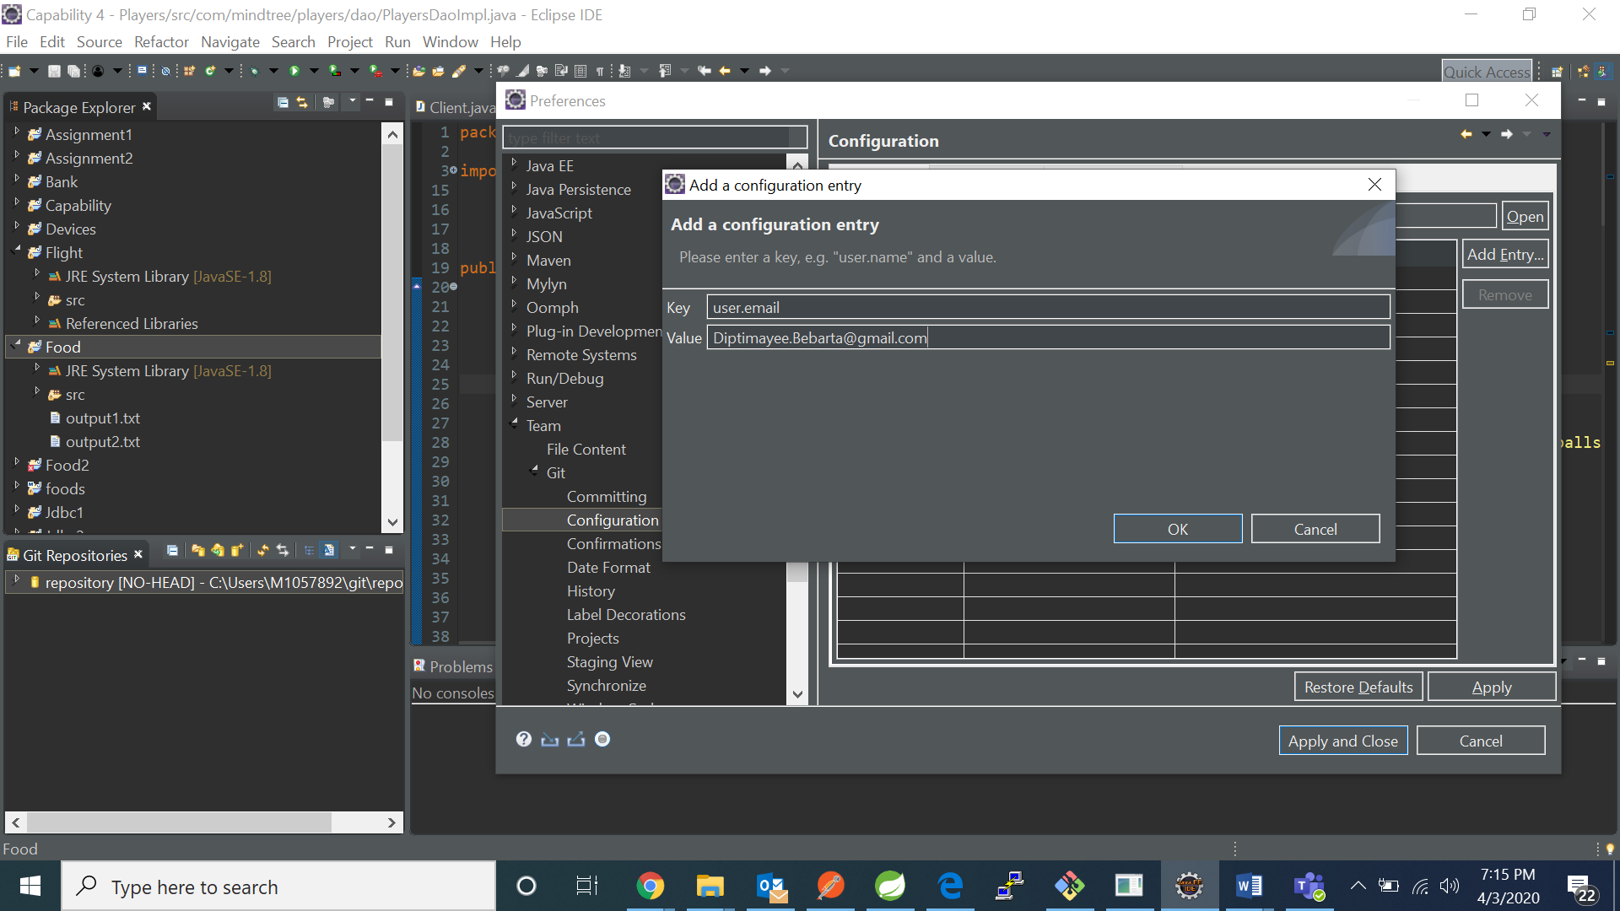
3. Then click on apply and then on apply and close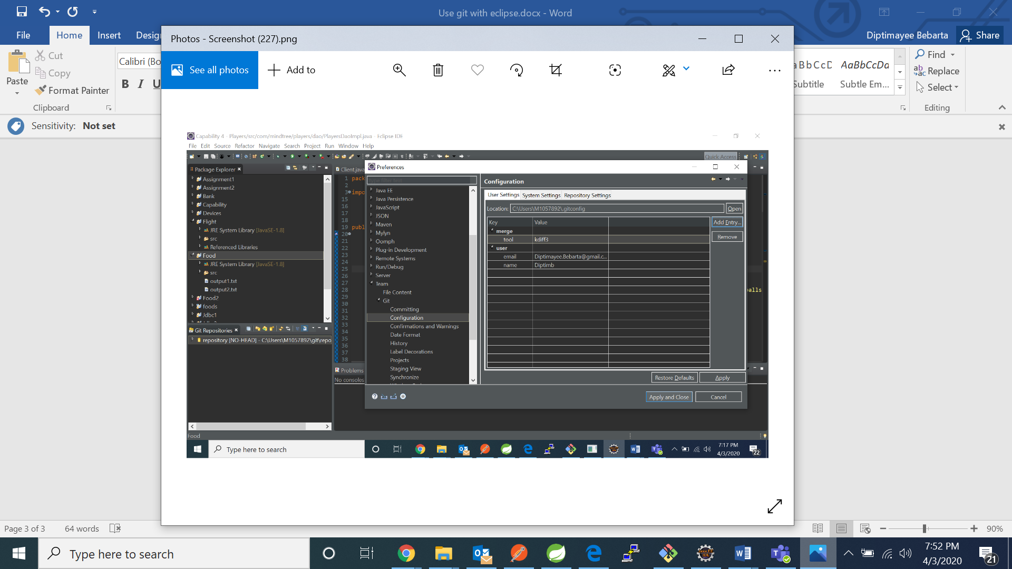
4. Goto Windows ->Show View ->Others

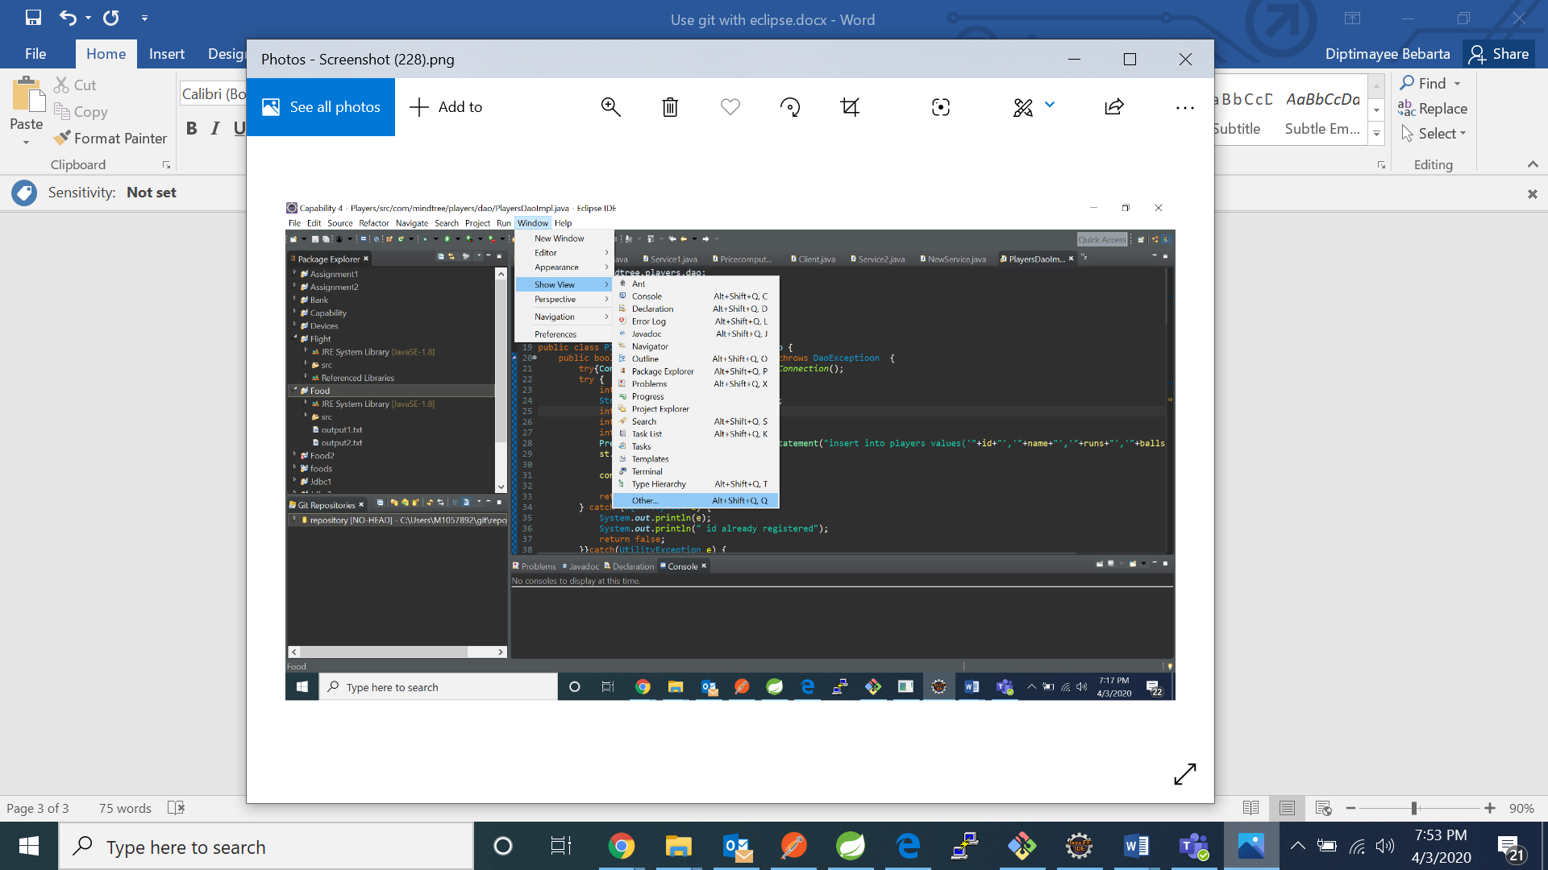

1. Search for git and click on git repository 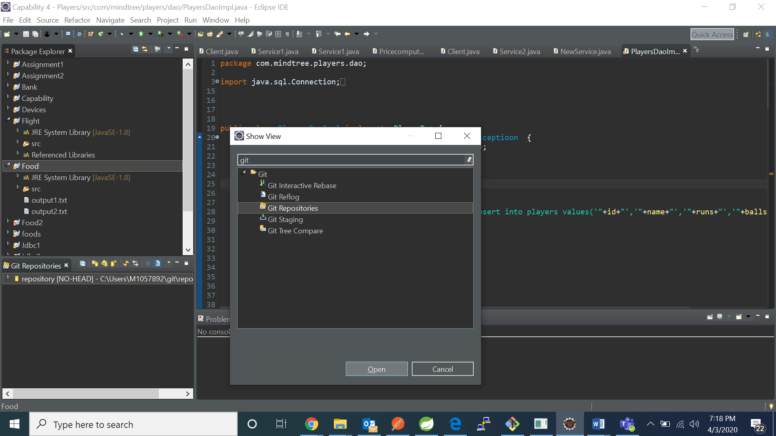
2. Now click on clone a git repository 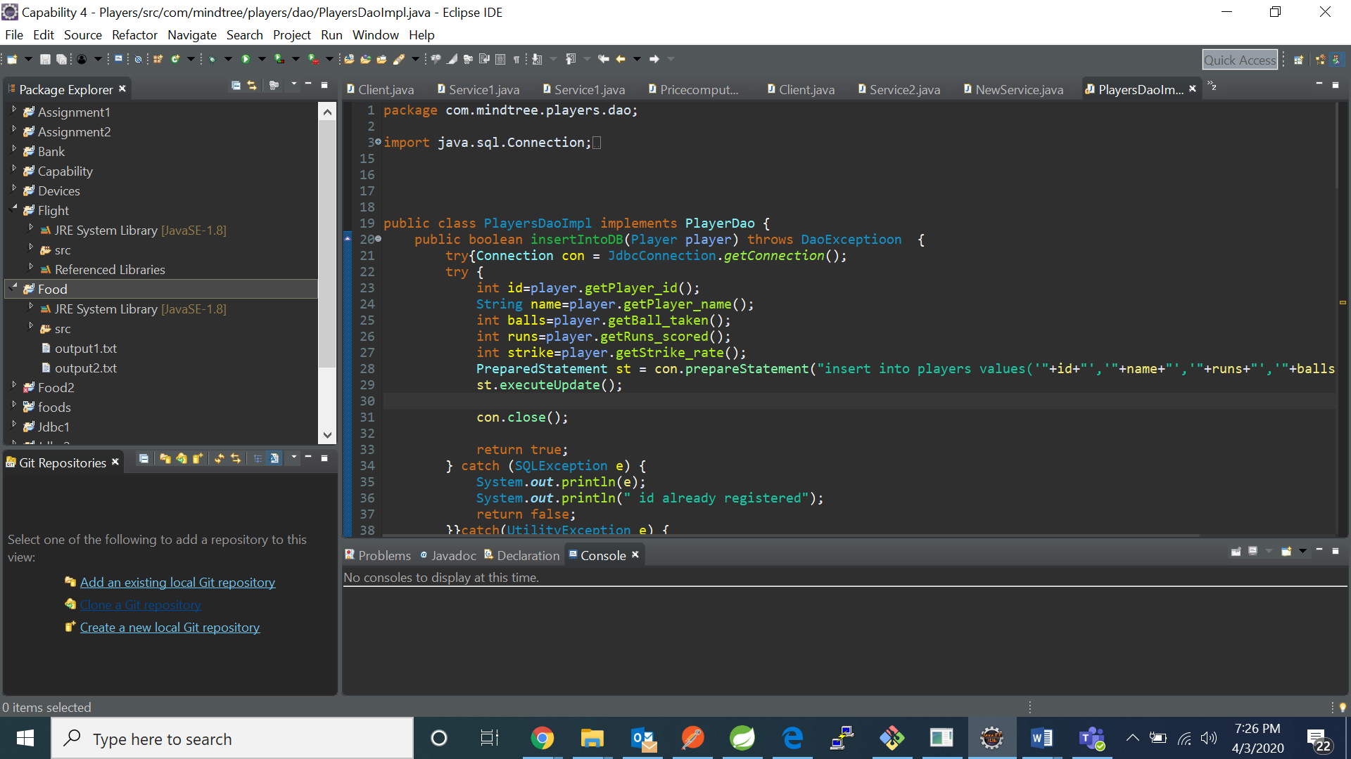
3. Enter your github url and all other credentials and click on next and then finish.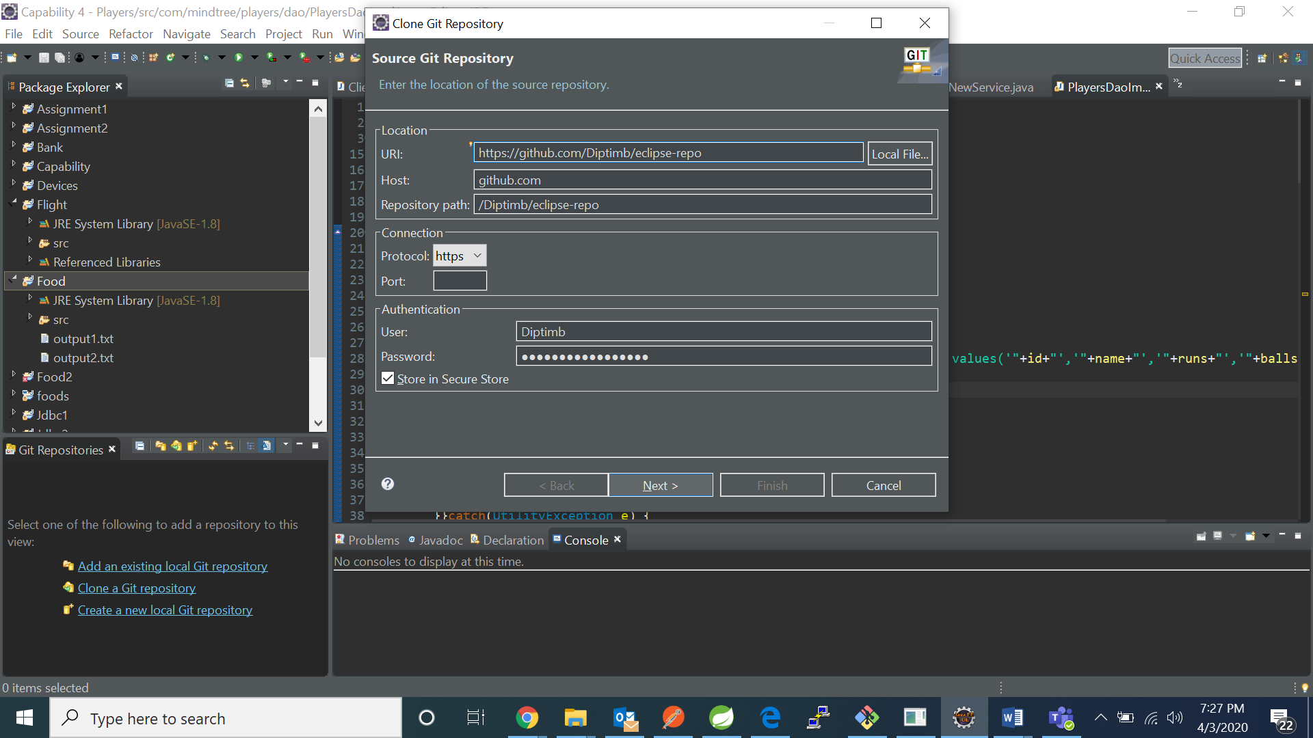

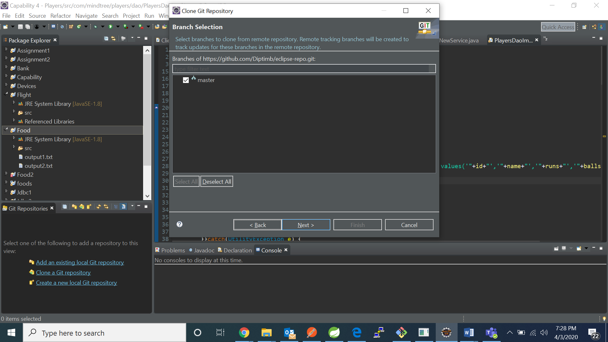

1. Now left click on project and go to team and then share project 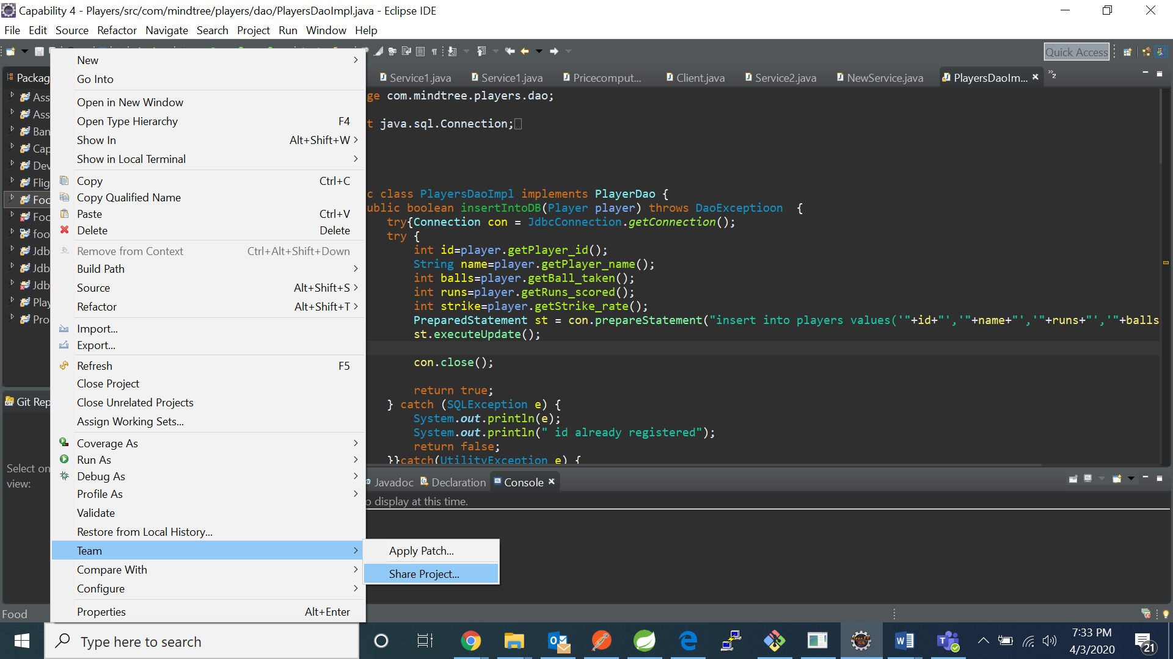
2. Now click on your local git repository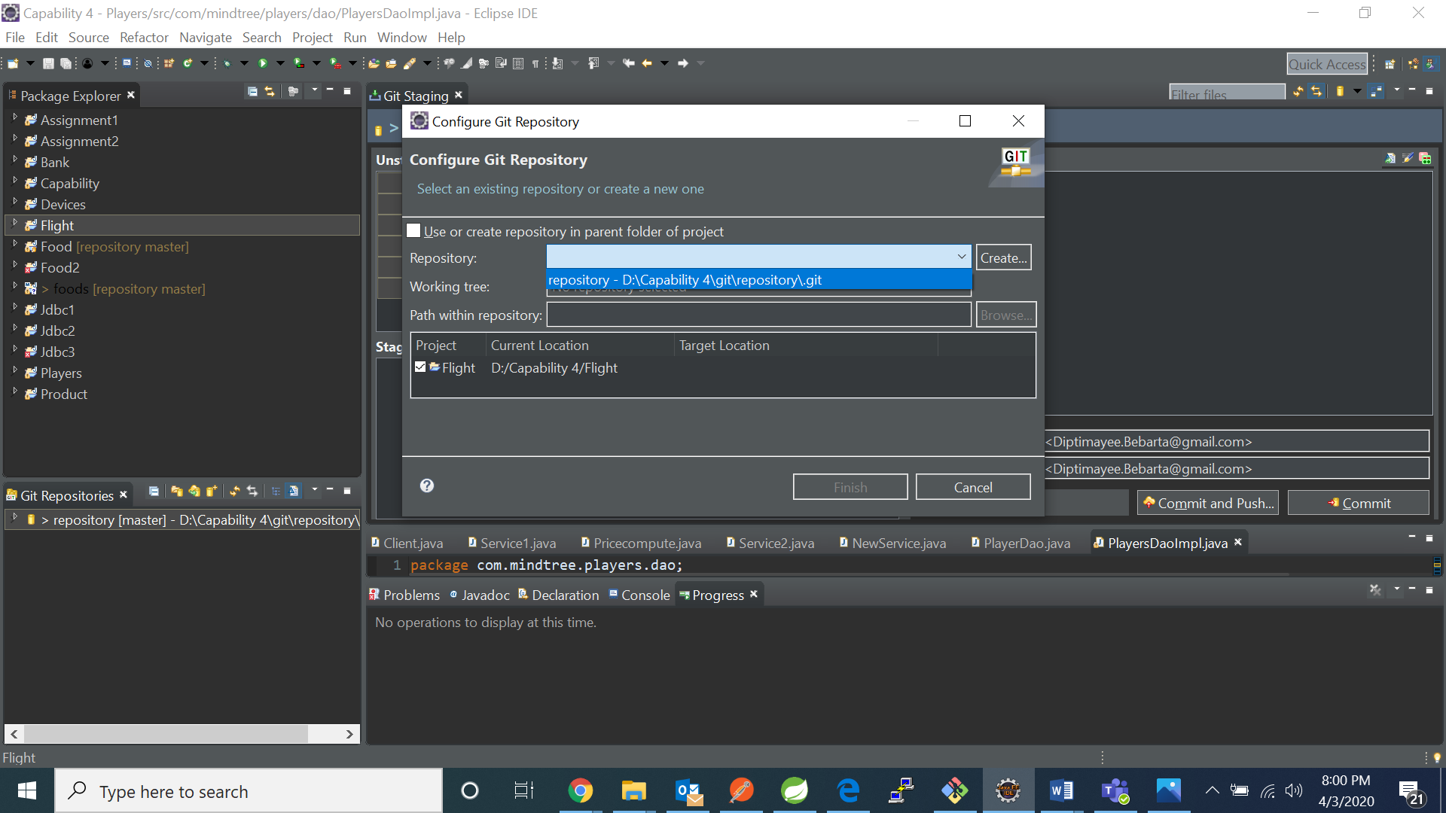

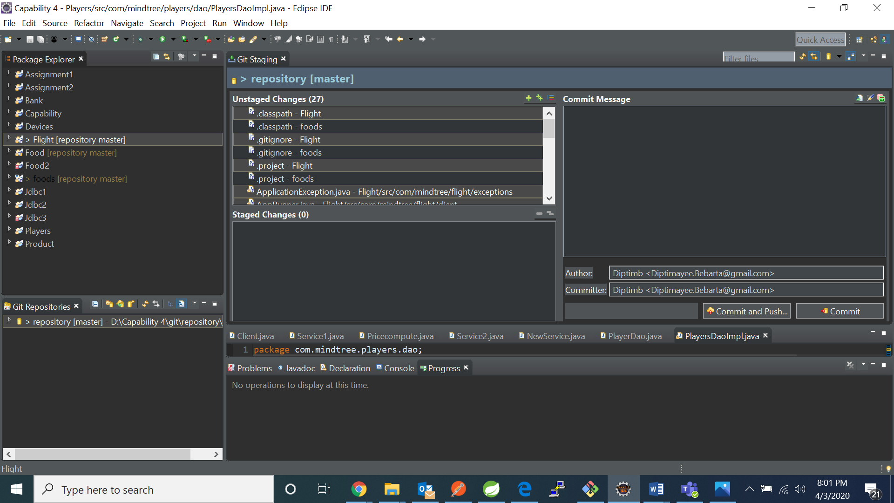

1. Now shift all the files from the unstaged changes to stages changed and add a commit message

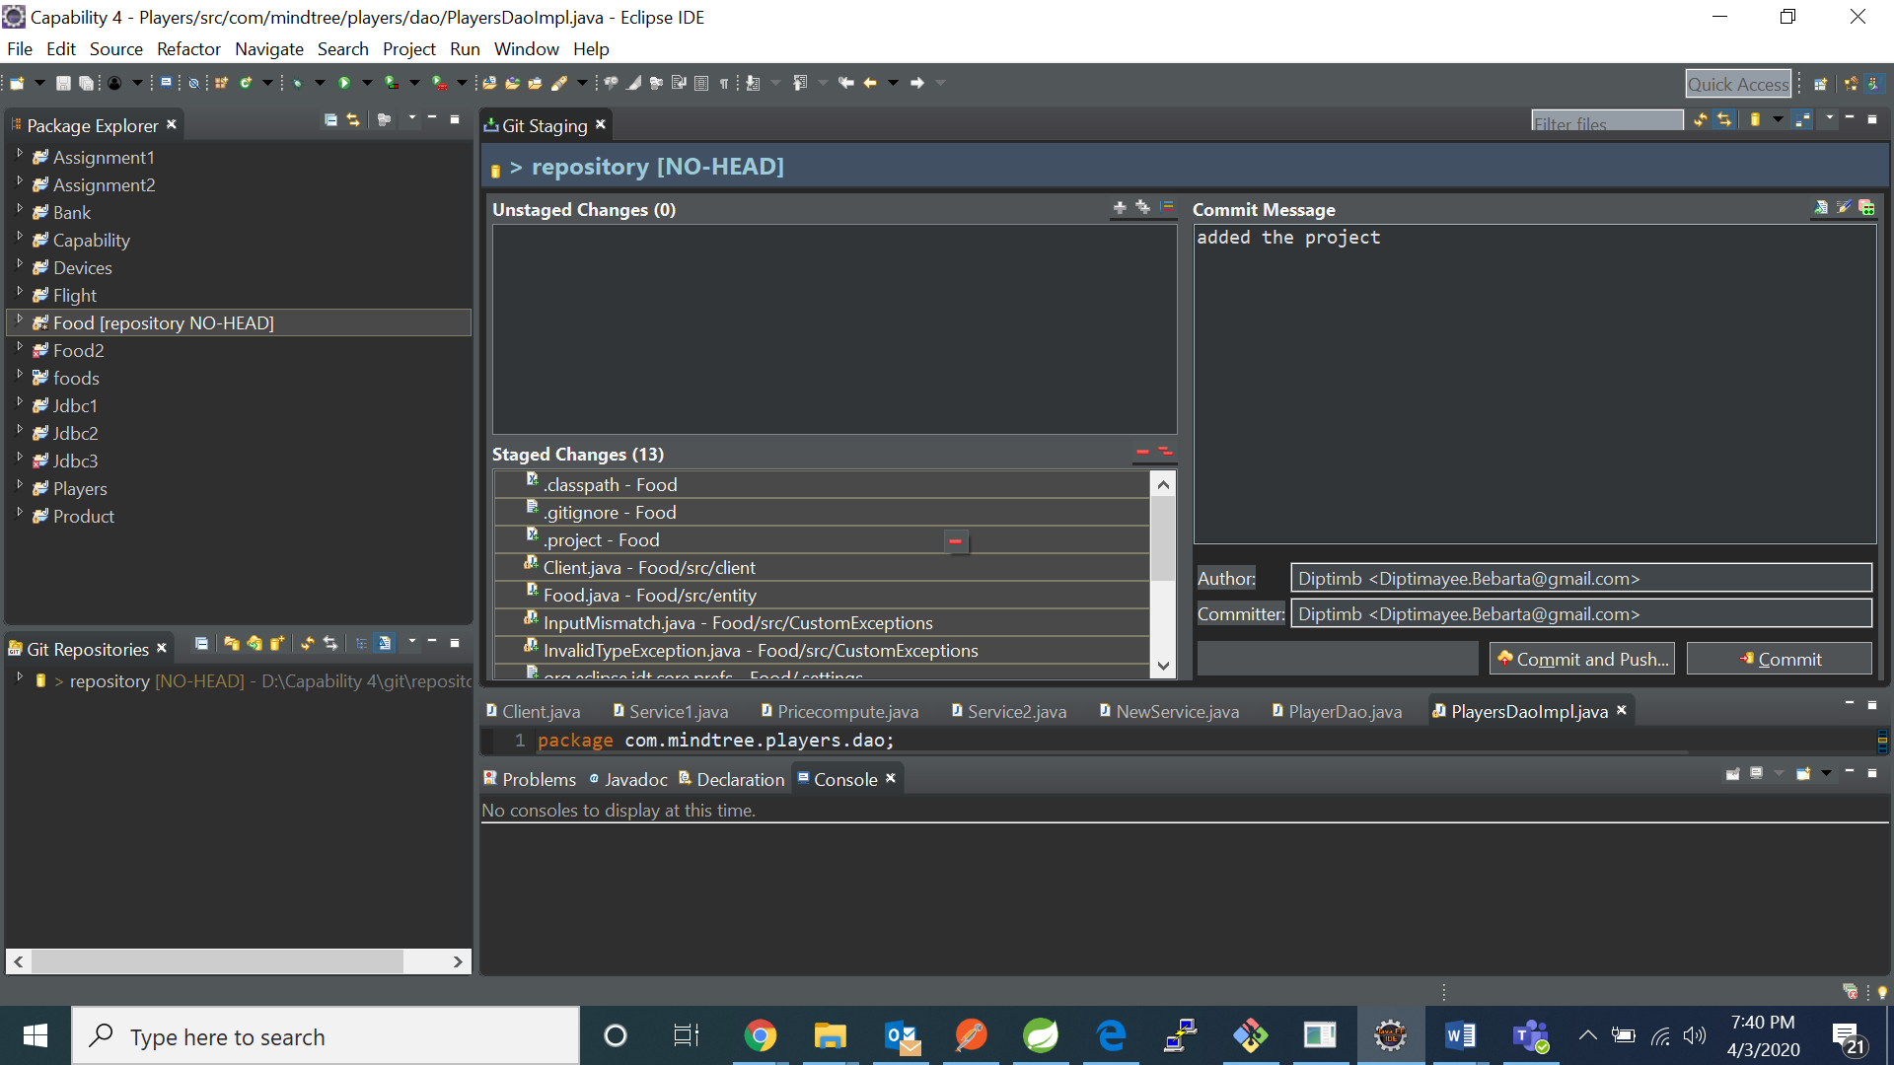

1. Now click on commit and push

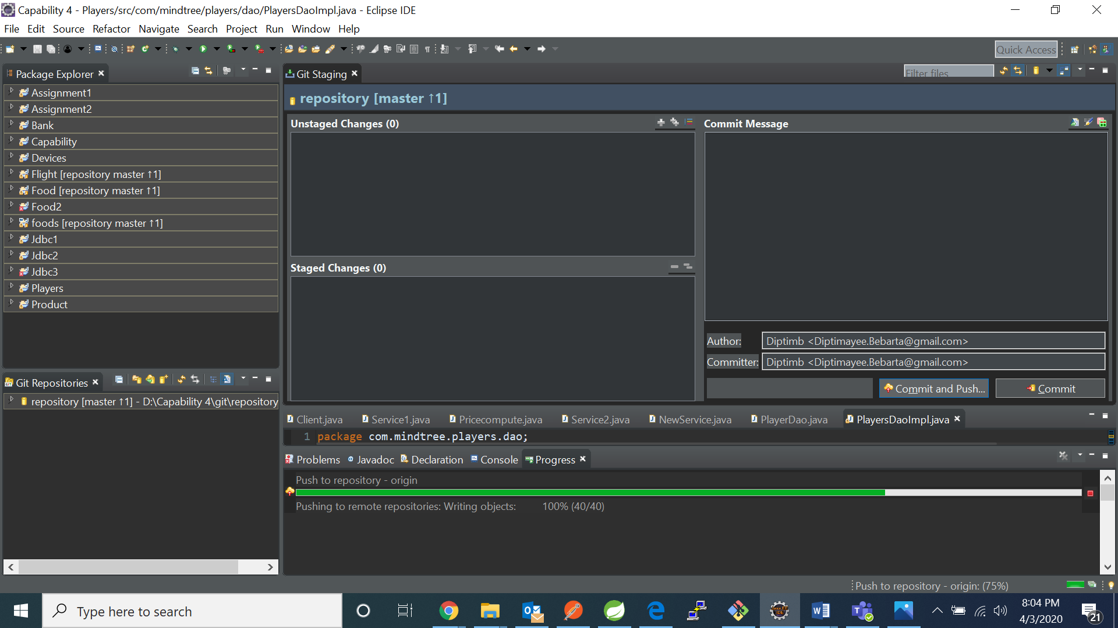

1. We can see the project has been pushed

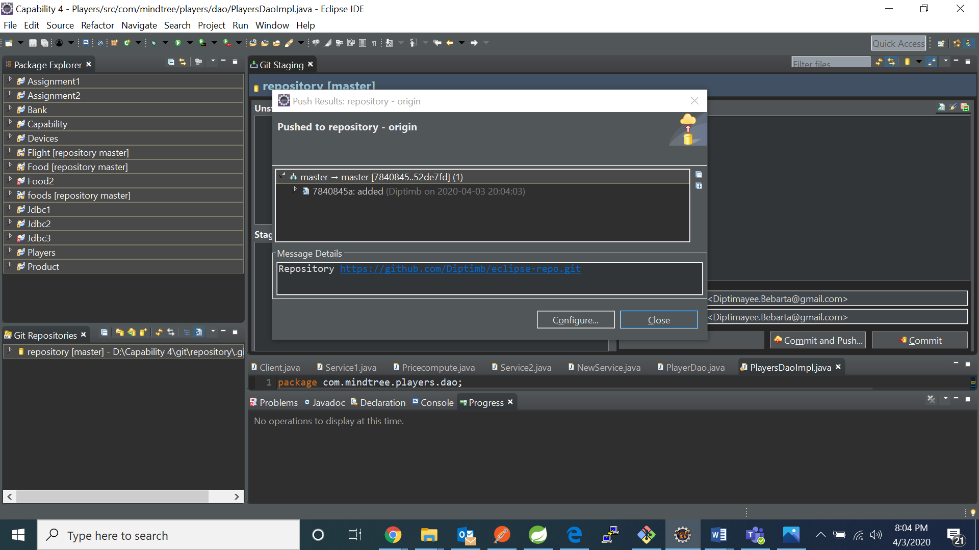

1